A Project Report On

**“Four Vedas Of India”**

Submitted To

**Savitribai Phule Pune University**

In partial fulfilment of the degree of

**Bachelor of Business Administration-Computer Applications**

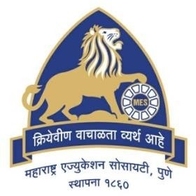

By

**Aishwarya Kadam (14422)**

BBA-CA SemesterIV

Under the guidance of

**Mrs. Padma Nene**

Research Guide

MES Garware College of Commerce , Autonomous

Karve Road, Pune 411004

(2022-2023)

**MES GARWARE COLLEGE OF COMMERCE,** **AUTONOMOUS**

**PUNE-411004.**

**BACHELOR OF BUSINESS ADMINISTRATION – COMPUTER APPLICATION**

# CERTIFICATE

This is to certify that **Miss. Aishwarya Kadam** Roll Number **14422** University Exam Seat Number**_____________ Student** of **SY BBA-CA Semester-IV** has successfully completed the project work in specialization subject **Project based on HTML,** **CSS and JavaScript** entitled as **“Four Vedas Of India”** a partial fulfillment of the degree of Bachelors of Business Administration Computer Application as per the syllabus of Savitribai Phule Pune University Year 2022-2023.

I further clarify that , the work has been carried out under my supervision.

Project Guide BBA Co-ordinator Principal

Internal Examiner External Examiner

**Acknowledgement**

A successful project is the result of the hard work and great teamwork put together with the guidance of a proper mentor.

We would like to express our deep gratitude towards our project guide Mrs Padma Nene for her constant guidance and suggestions.

# 

# Index

|  |  |
| --- | --- |
| 1 | Introduction |
| 2 | Objectives |
| 3 | Scope |
| 4 | Hardware and Software |
| 5 | System Design |
| 6 | Layout of the Website |
| 7 | Limitations |
| 8 | Conclusion |
| 9 | Bibliography |

# Introduction

Welcome to the world of Vedas! Vedas are ancient texts of India that date back to over 5,000 years ago. They are considered to be the oldest known scriptures in the world and are revered as the source of all knowledge.

The Vedas are a vast collection of hymns, prayers, and philosophical texts that are divided into four main categories: the Rigveda, Yajurveda, Samaveda, and Atharvaveda. These texts cover a wide range of subjects including spirituality, philosophy, science, medicine, and astrology.

The Vedas are not just a religious text, but a source of wisdom that is still relevant today. They provide a glimpse into the rich cultural heritage of India and have influenced many spiritual and philosophical movements around the world.

Through this website, we aim to provide a comprehensive resource for anyone interested in learning more about the Vedas. Here, you will find information about the history and significance of the Vedas, as well as translations and commentary on the various texts. We hope that this website will be a valuable resource for all those seeking to deepen their understanding of this ancient and profound tradition.

**Objectives**

* a website that helps user to learn more about Vedas
* convey the importance of Vedas to user
* Provide information on various types of Vedas
* Detailed information about :

Rigveda

Yajurveda

Samaveda

Atharvaveda

# Scope

Historical Context and Significance: Providing information on the origins and development of the Vedas, their significance in Hinduism and Indian culture

Rituals and Practices: Providing information on Vedic rituals and practices, such as yajnas, mantras, and meditation, and how they are still practiced today.

Spirituality and Philosophy: Exploring the spiritual and philosophical teachings of the Vedas, including the concepts of dharma, karma, and moksha.

Education and Learning: Offering educational resources and tools of the Vedas, including online books , PDFs, websites, and videos .

**Hardware and Software**

## ●Minimum Hardware Requirements

System Processor: Intel Corei3

Memory: 1.00GB RAM or More

Additional Devices- USB Drive and Printer

## ●Minimum Software Requirements

OS- Windows 10

Front End- Visual Basics 6.0

**Languages Using**

HTML

CSS

JAVASCRIPT

# System Design

ERD

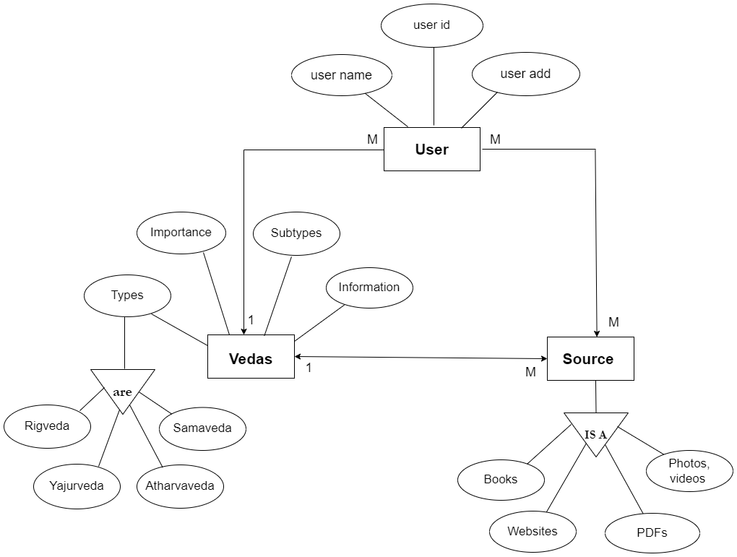

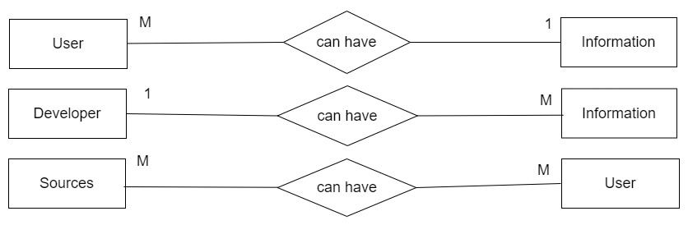

DFD

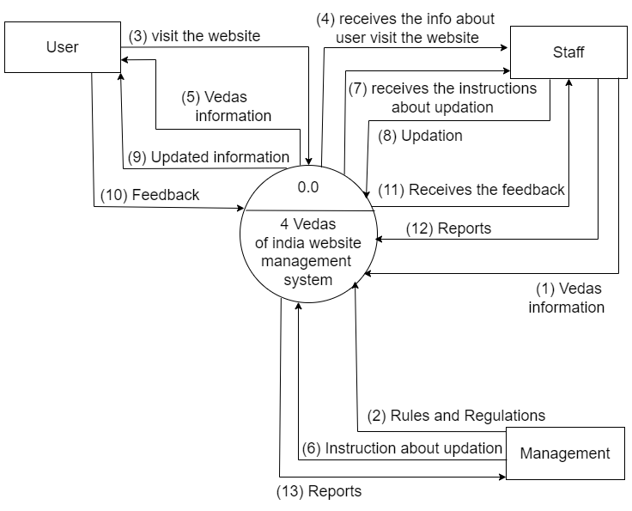

**Layout of the website**

Home Page :

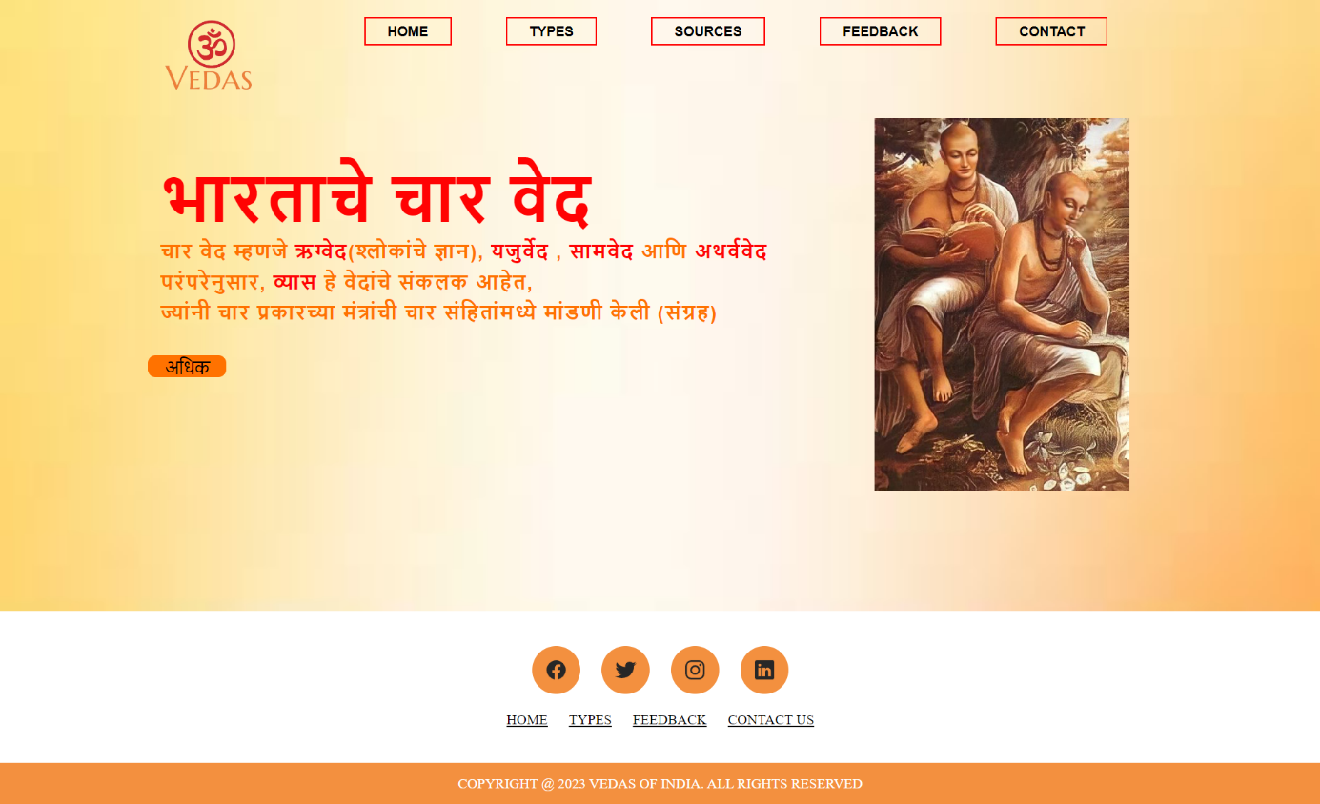

More Page :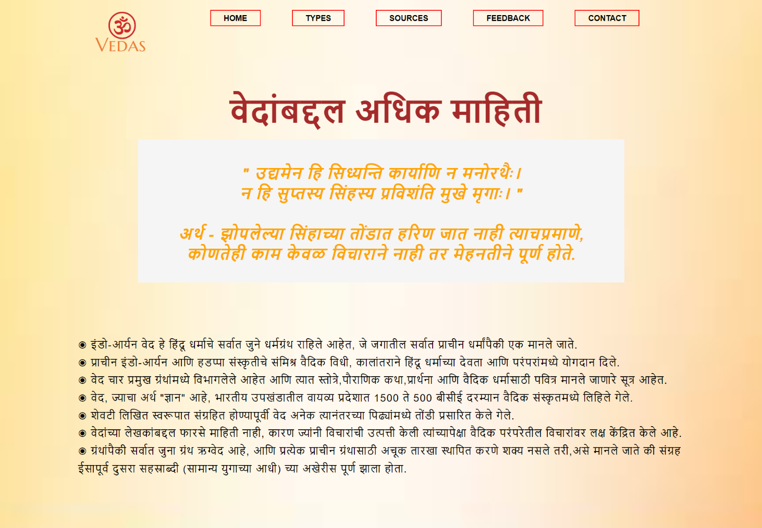

Type Page:

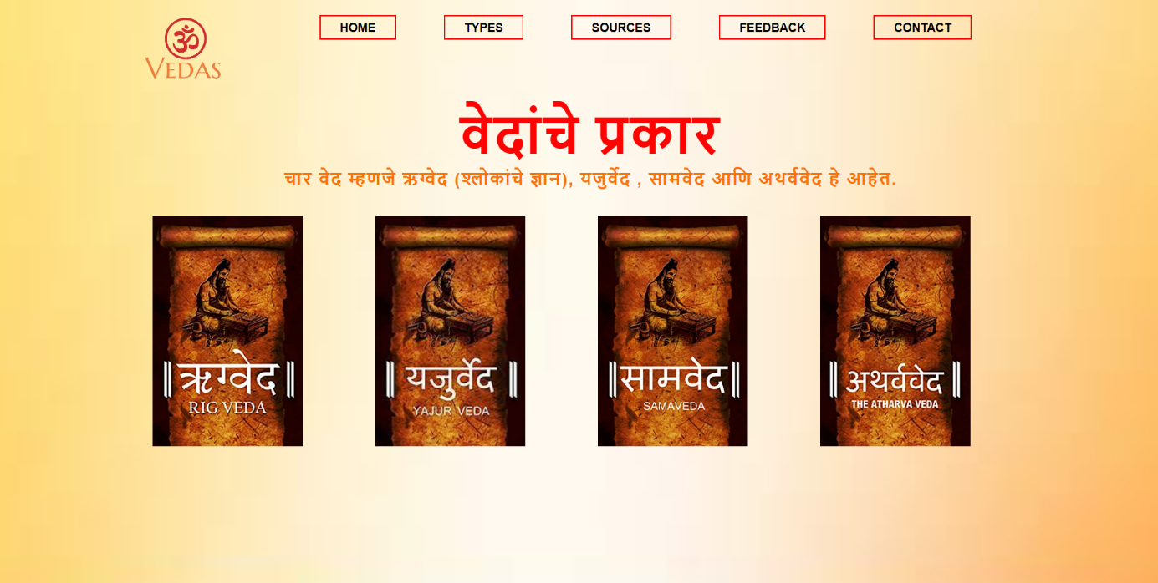

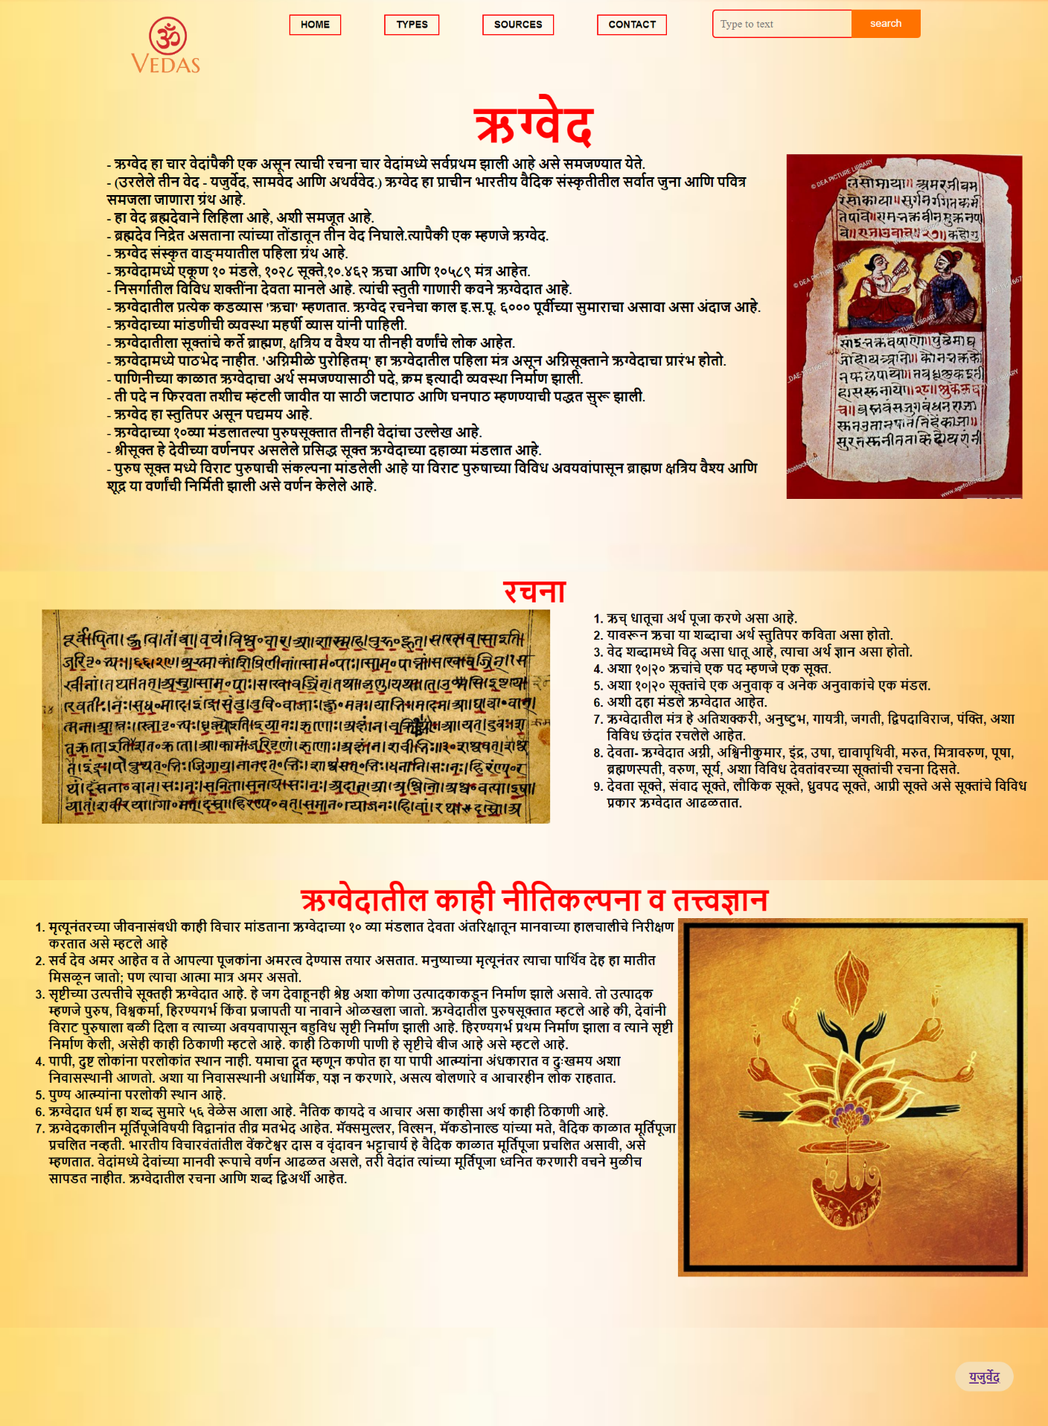

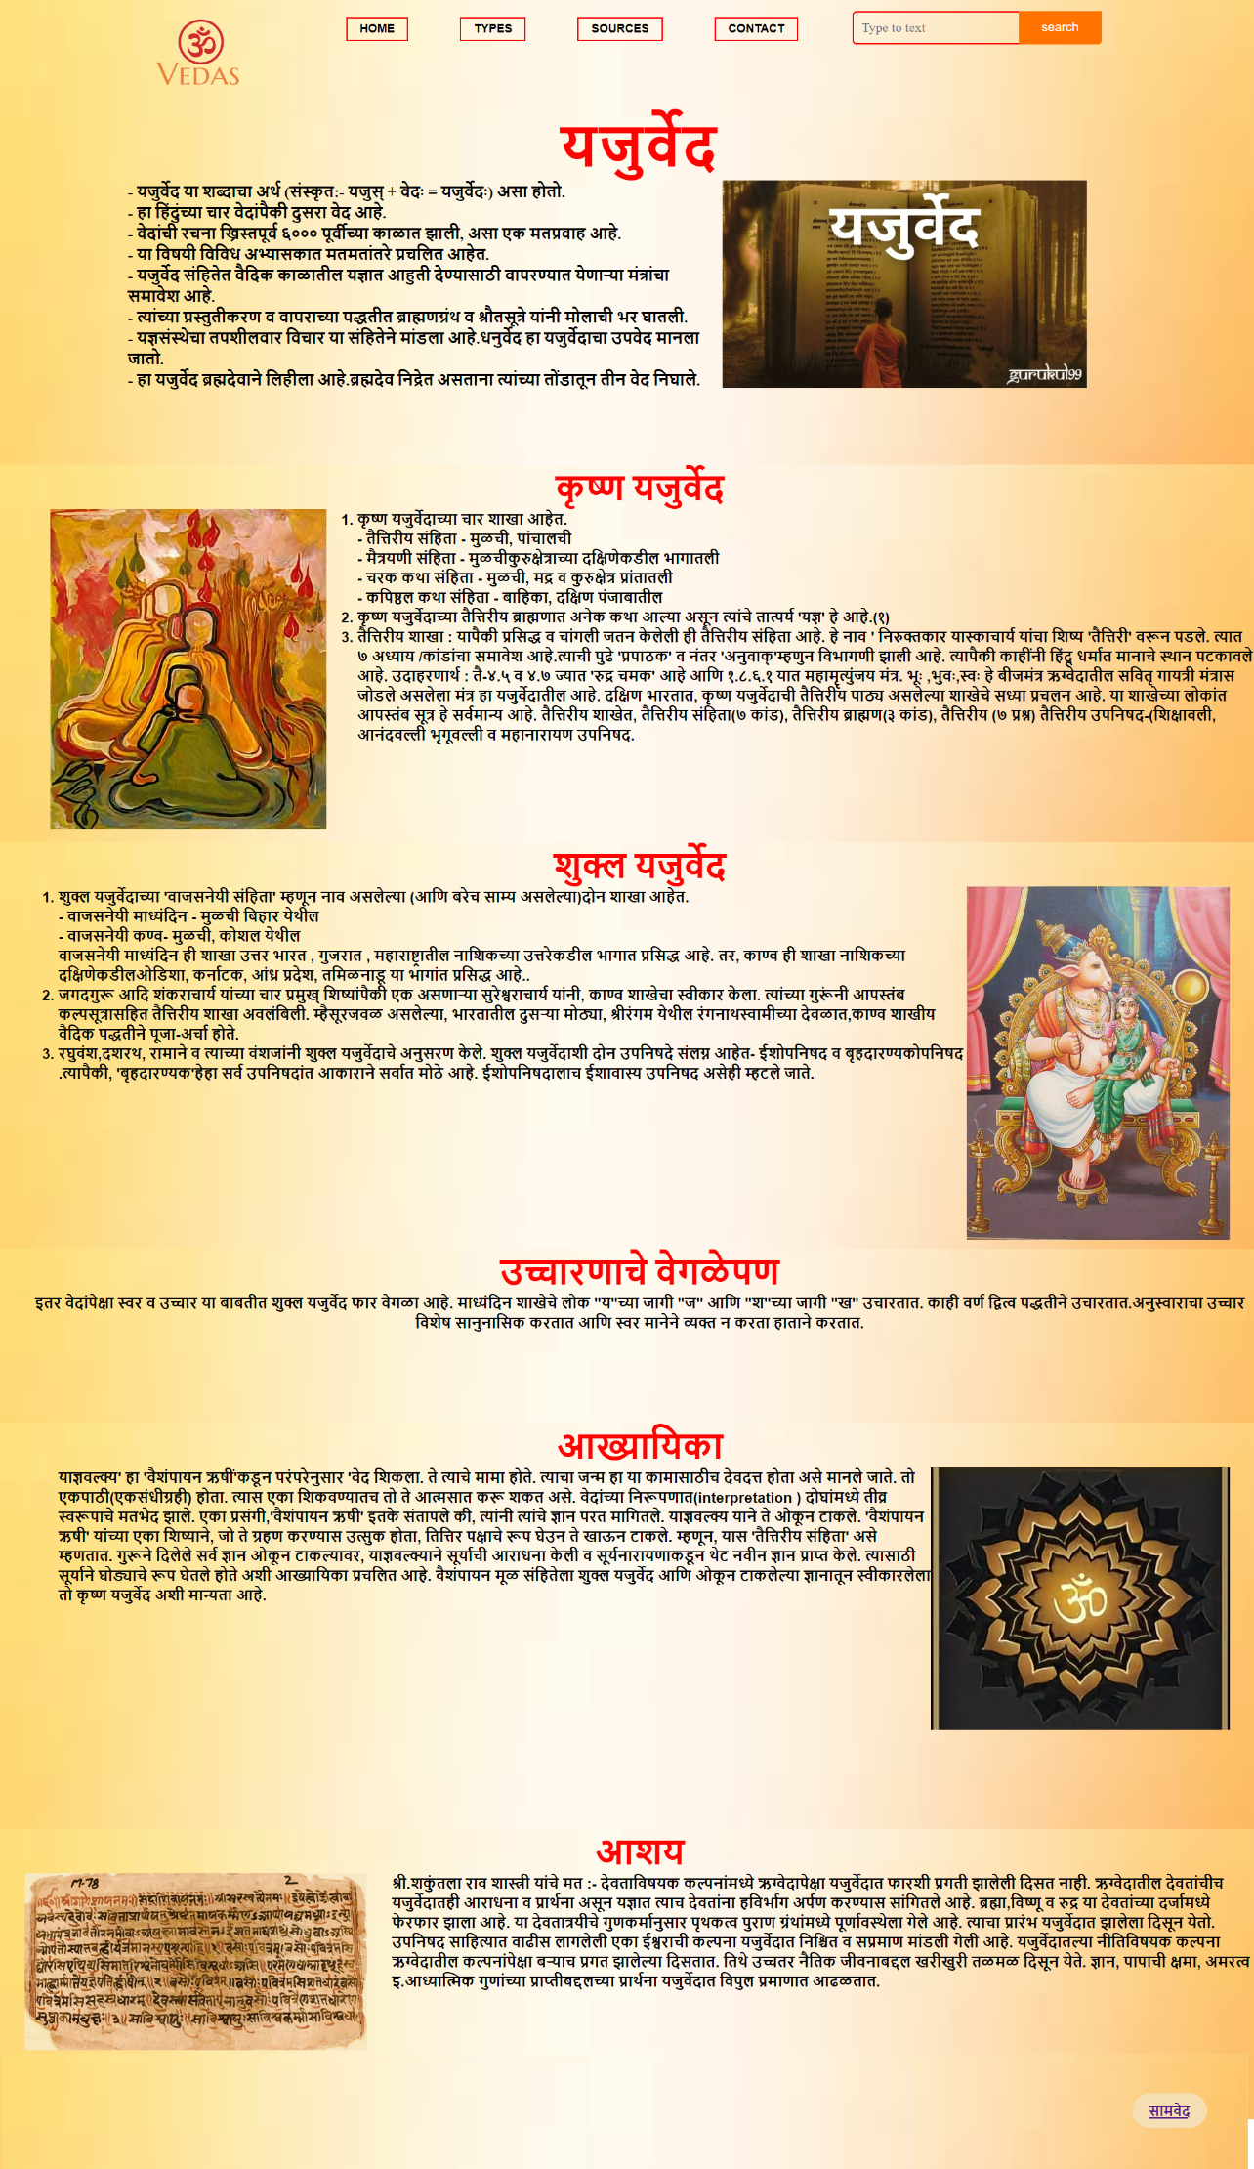

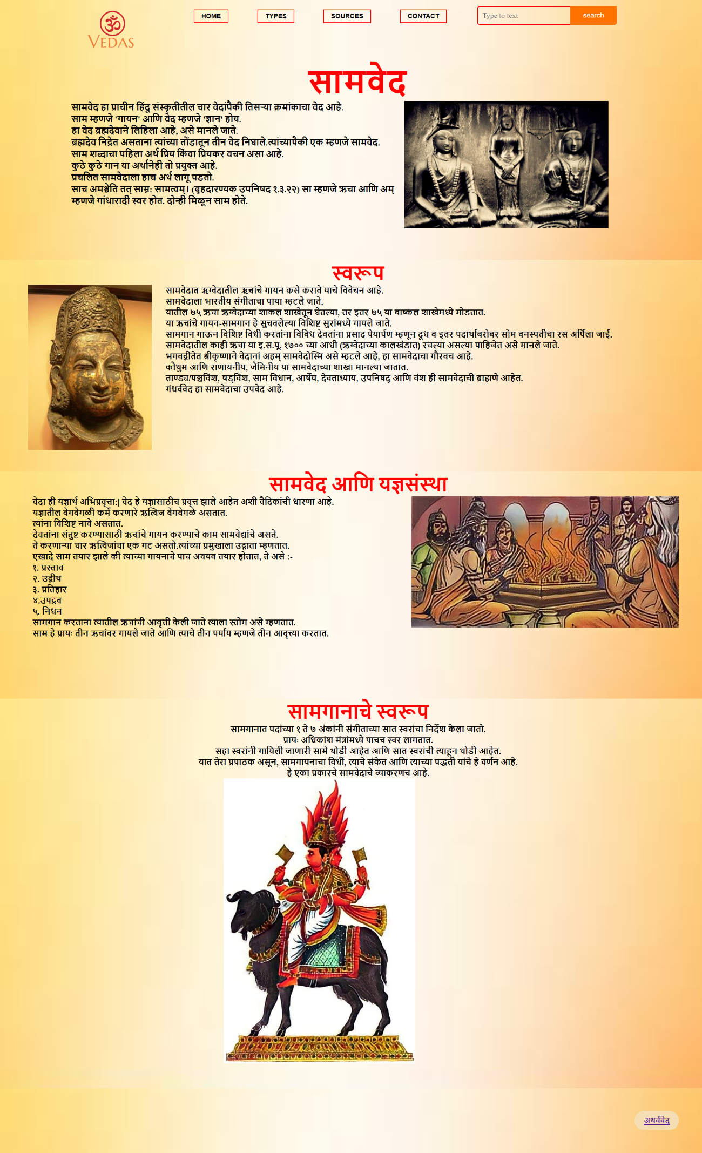

# 

# Source Page:

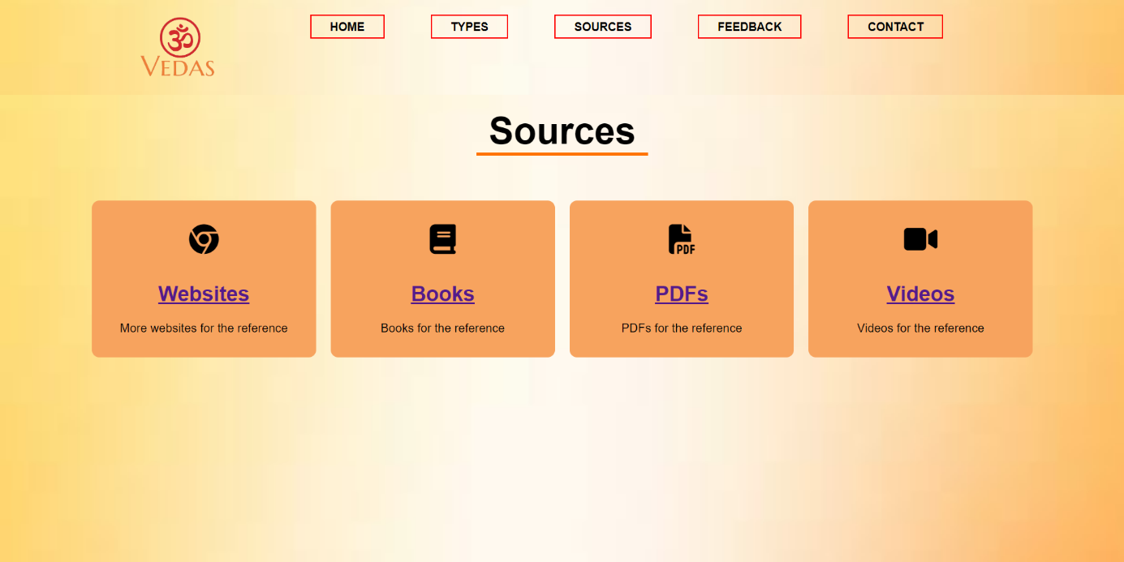

Websites Page:

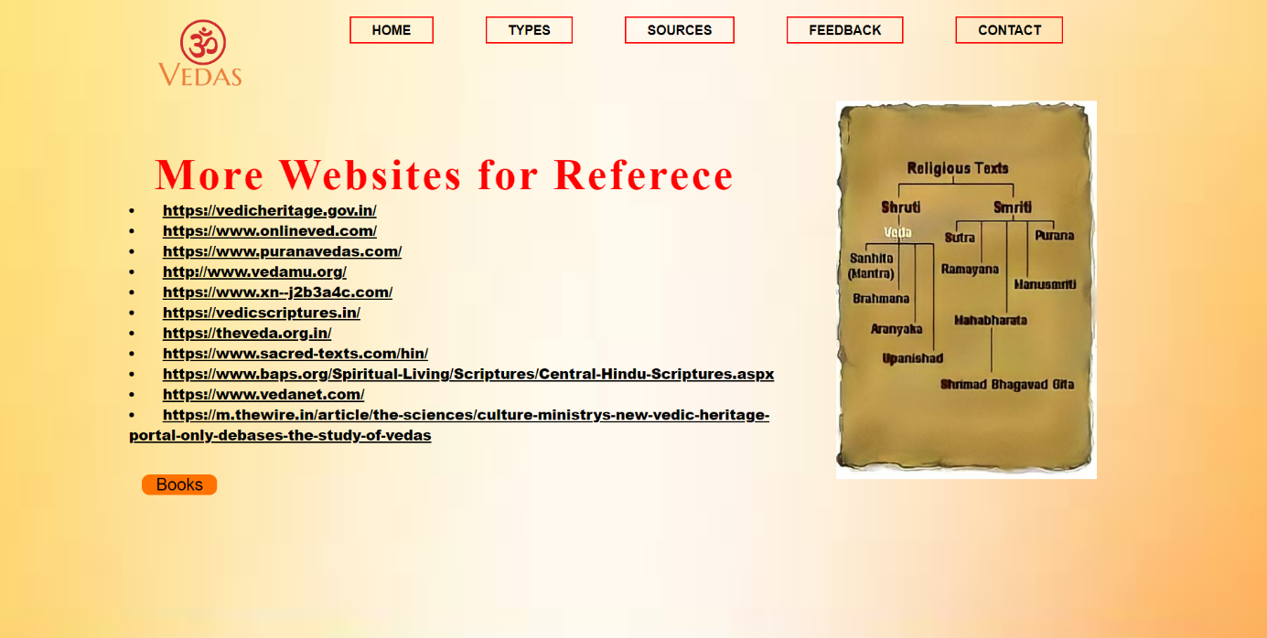

# Books Page:

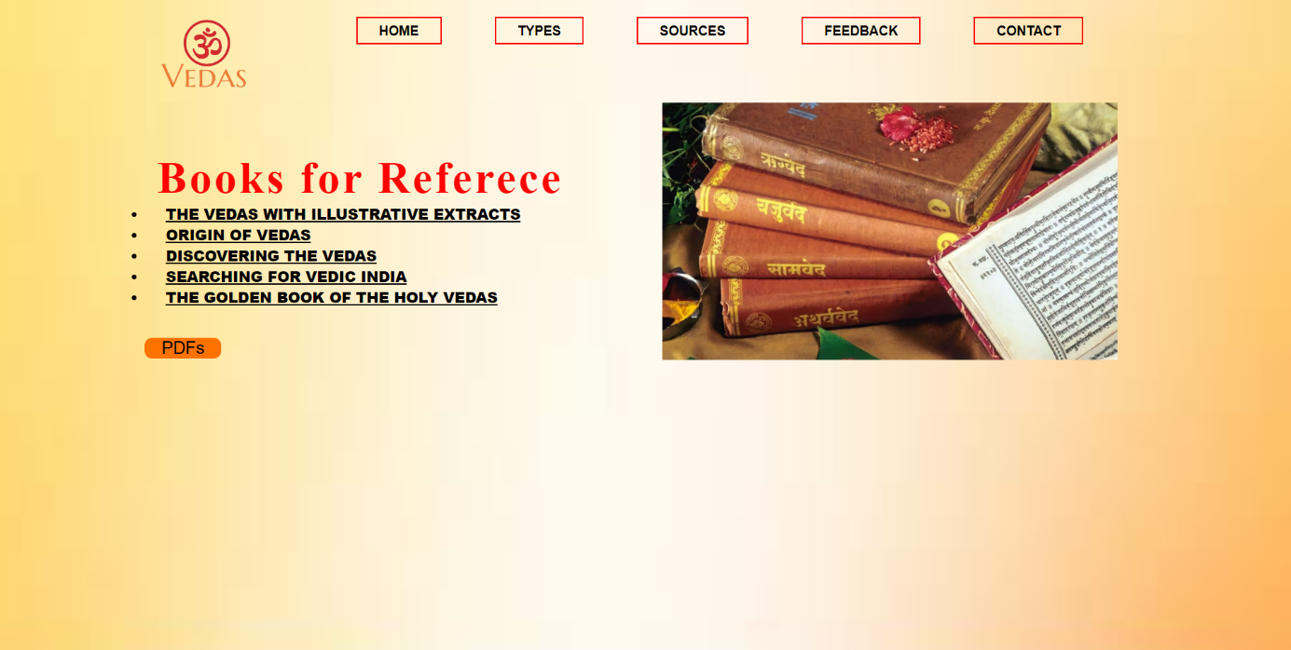

PDFs Page:

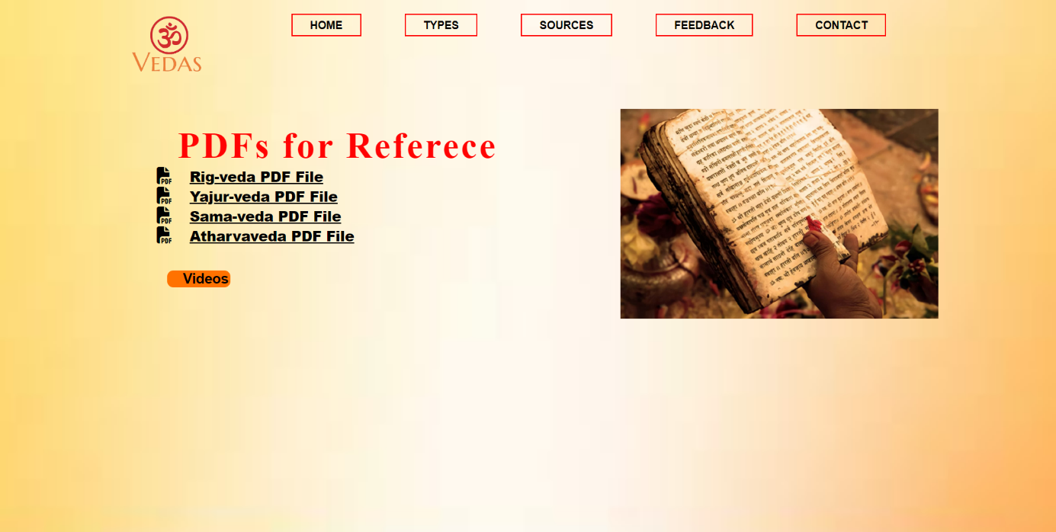

# Videos page:

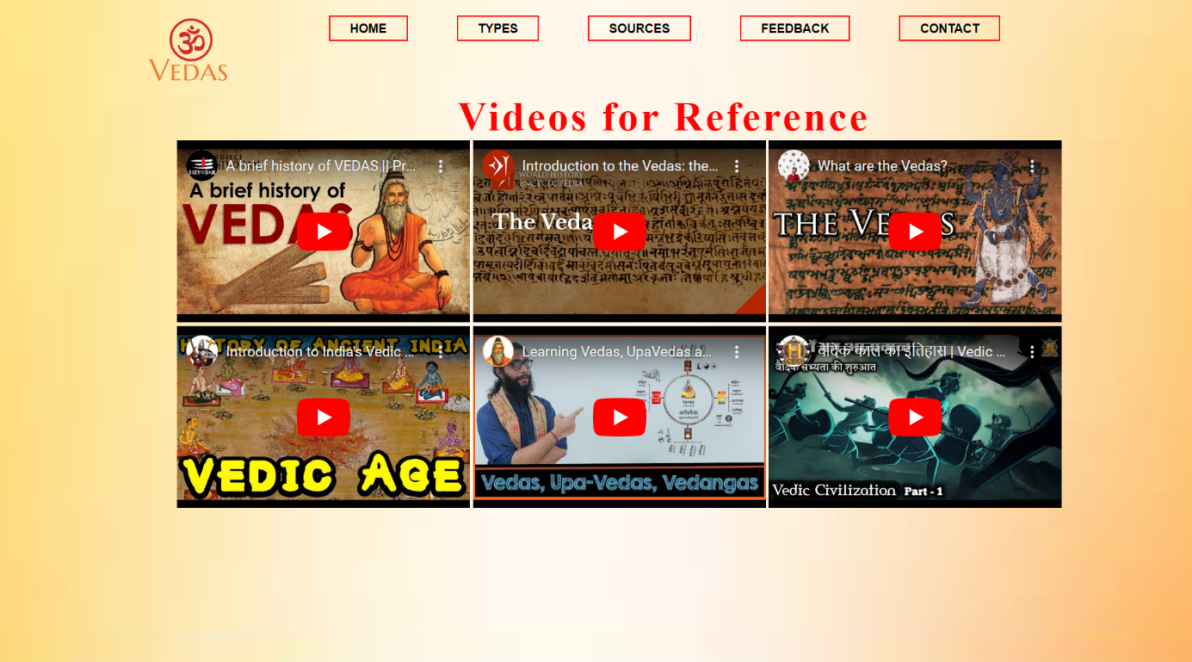

Feedback Page:

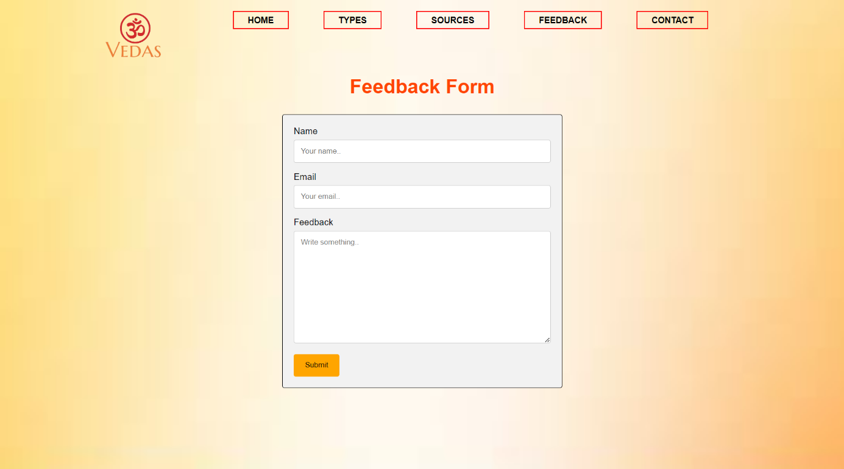

Contact page:

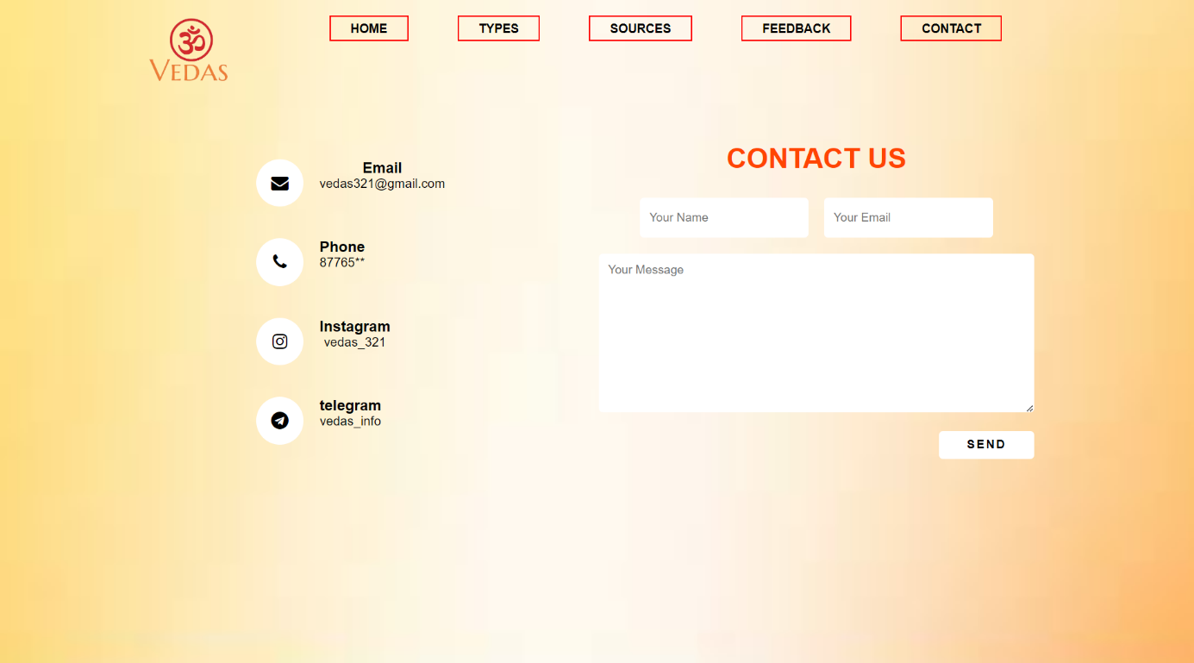

# Conclusion

A Vedas website can have a wide scope covering many different areas related to the ancient Hindu scriptures.

It can provide historical context and significance, offer translations and interpretations of Vedic texts, discuss Vedic rituals and practices, explore spiritual and philosophical teachings, discuss cultural and social relevance, address contemporary issues and debates, compare Vedic teachings with other religious and philosophical traditions, and offer educational resources of the Vedas.

Overall, a Vedas website can be a valuable resource for anyone interested in learning about the Vedas, their teachings, and their impact on Hinduism and world culture.

**References**

* Doniger , Wendy. The Rig Veda: An Anthology: One Hundred and Eight Hymns, Selected, Translated and Annotated. Penguin Books, 1981.
* MacDonell, Arthur A. A History of Sanskrit Literature. Kessinger Publishing, 2004.
* Radhakrishnan, Sarvepalli. The Principal Upanishads. HarperCollins Publishers India, 1994.

www.hinduwebsite.com/sacredscripts/vedas/index.asp - This website provides a comprehensive overview of the Vedas and includes translations and commentaries on select Vedic hymns.

www.vedpuran.net - This website offers translations and commentaries on the Vedas, as well as other Hindu scriptures and texts.

www.swamij.com/vedas.htm - This website offers a brief introduction to the Vedas and includes links to other resources on Vedic philosophy and practices.

www.indiadivine.org/vedas - This website provides information on the Vedas, as well as other aspects of Hinduism, including yoga, meditation, and Ayurveda.

www.vedanet.com - This website offers resources on Vedic knowledge and includes articles, books, and courses on Vedic philosophy, spirituality, and practices.